About Transport Layer Security (TLS)
Transport Layer Security (TLS) is a protocol that ensures that a connection to a remote endpoint is securely encrypted in order to provide privacy and data integrity. Fiserv web applications and application programing interface (API) connections use TLS as a key component of their security. TLS 1.0 and 1.1 are earlier, now less secure versions.

TLS Preparations
If your browser is not listed below please enable Transport Layer Security
(TLS 1.2) as show in instructions below.
Browsers and Operating Systems | TSL 1.2 Compatibility Notes
Microsoft Edge | Compatible by default
Microsoft IE Desktop and mobile version 11 | Compatible by default
Microsoft IE Desktop versions 9 and 10 | Capable when run in Windows 7 or newer, but not enabled by default
Firefox 27 and higher | Compatible by default
Google Chrome 38 and higher | Compatible by default
Oracle Java version 1.7 and higher | Compatible by default
Mobile Safari versions 5 and higher | Compatible by default
Microsoft Windows Server 2008 R2 and higher | Not compatible with TLS 1.2
Microsoft Windows 7, 8.0, 8.1 and 10 | Compatible by default
Microsoft XP/Vista and below | Not compatible with TLS 1.2

How to Enable Transport Layer Security (TLS) 1.2
- From your internet browser, select Tools, then Internet Options.
- Click the Advanced Tab, and scroll down to Security section.

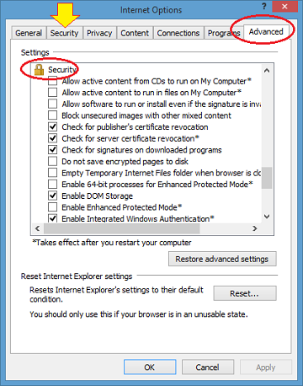

- Ensure TLS 1.2 is checked, if not check TLS 1.2 and select, Apply, OK.

